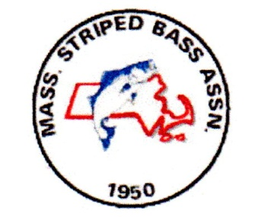MSBA 2020 Annual Sport Fishing Expo

REPLY BY EMAIL TO: FISHBOAT44@COMCAST.NET, OR MSBAEXPO@GMAIL.COM.
MAIL YOUR PAYMENT TO THE ADDRESS BELOW.

PAYMENT POLICIES

Booth placement policy is First Paid in Full – First Placed

Send A Non Refundable $25.00 Deposit PER BOOTH to Guarantee Space

Full Payment Due by January 15, 2020

Amount included with this form $___________

Make check payable to: MSBA EXPO

Mail to: MSBA EXPO

49 Hamilton Drive

Pembroke, MA 02359

MSBA 2020 Annual Sport Fishing Expo

THIS PAGE MUST BE FILLED OUT AND RETURNED

Business Name: ______________________________________

Contact Name: _______________________________________

Street Address: _______________________________________

Town: ___________________ State: _____ Zip Code: ___________

Email: ____________________________ Phone Number: _________

Booth rental includes 1 – 8’ table and 2 folding chairs per booth.

Items Ordered

8’ X 10’ booth space @ $ 275.00 Cost _____________

8’ X 20’ booth space @ $ 475.00 Cost _____________

8’ X 30’ booth space @ $ 675.00 Cost _____________

Additional 8’ X 10’ booth @ $ 200.00 Cost _____________

Total Cost _____________

MSBA 2020 Annual Sport Fishing Expo

THIS PAGE MUST BE FILLED OUT AND RETURNED

EXHIBITOR OPERATIONS POLICY DOCUMENT

( 1 ) Vendor Badges will be required to enter the vendor entrance (rear door)

( 2 ) Vendors may leave badges ONLY at the vendor check in table (side door). All vendors must check in at the vendor entrance (side door).

( 3 ) Each vendor will receive FOUR badges. Please list names below

- ___________________________ 3. ______________________________

- ___________________________ 4. _______________________________

( 4 ) Vendors are responsible for knowing, and following all pertinent laws, having proper permits, and following tax procedures related to their participation in this event.

( 5 ) By signing this agreement, Vendor representatives acknowledge they have been informed of these policies, commit to follow these policies and take responsibility for informing your staff.

Signature: ____________________________________________

Print Name: ____________________________________________

Company: ____________________________________________

